

Programming Fundamentals

Student Name :MOMIN HAYAT KHAN

Roll No: S20-0273

Department :BS(Artificial Intelligence)

Batch / Year:SPRING 2020

Lecturer: Mam Misbah

Assignment No 6

Program No 1:

|  |
| --- |
| #include <cmath> // defines the sqrt() function  #include <iostream>  using namespace std;  int main()  { // tests the sqrt() function:  for (int x=0; x <=9; x++)  cout << "\t" << x << "\t" <<sqrt(x)<<endl;} |

Output:

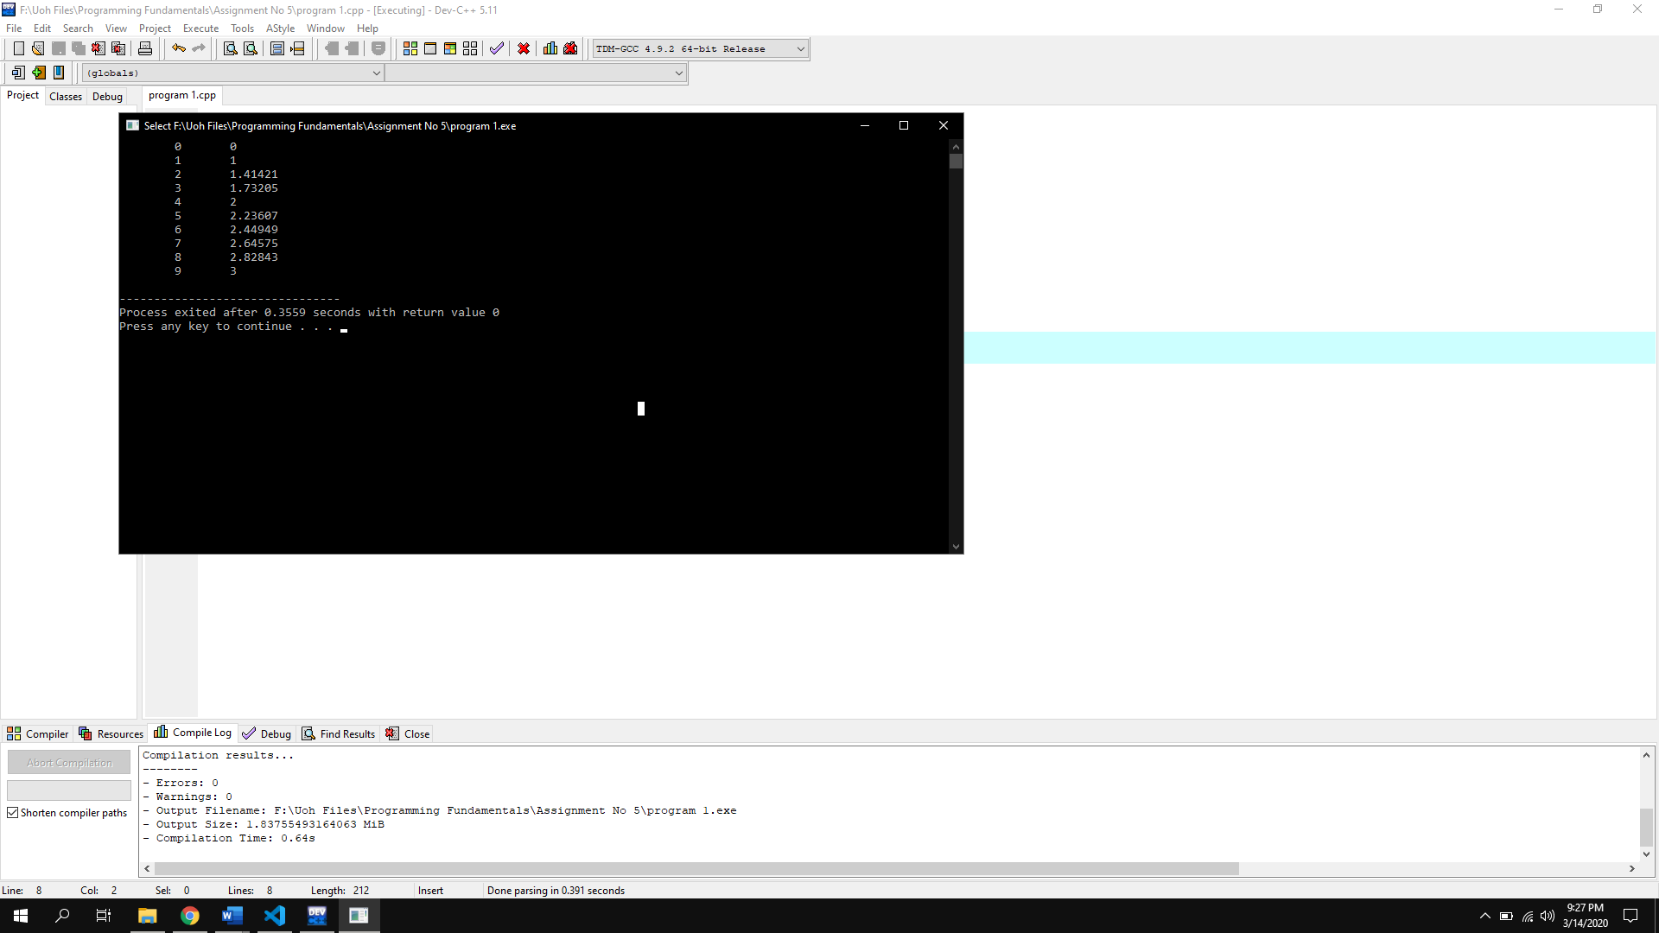

Types of Function:

|  |
| --- |
| There are two types of functions.   * User Defined function. * Pre Defined function. |

Syntax Of function (Prototype, call & body of function):

|  |
| --- |
| // Create a function void myFunction() {   cout << "I just got executed!"; }  int main() {   **myFunction();** // call the function   return 0;} |

Program No 2:

|  |
| --- |
| #include <iostream>  using namespace std;  void sqr(int a){  cout<<a*a;  }  int main()  { int a;  cout<<"Enter Integer= ";cin>>a;  sqr(a);} |

Output:

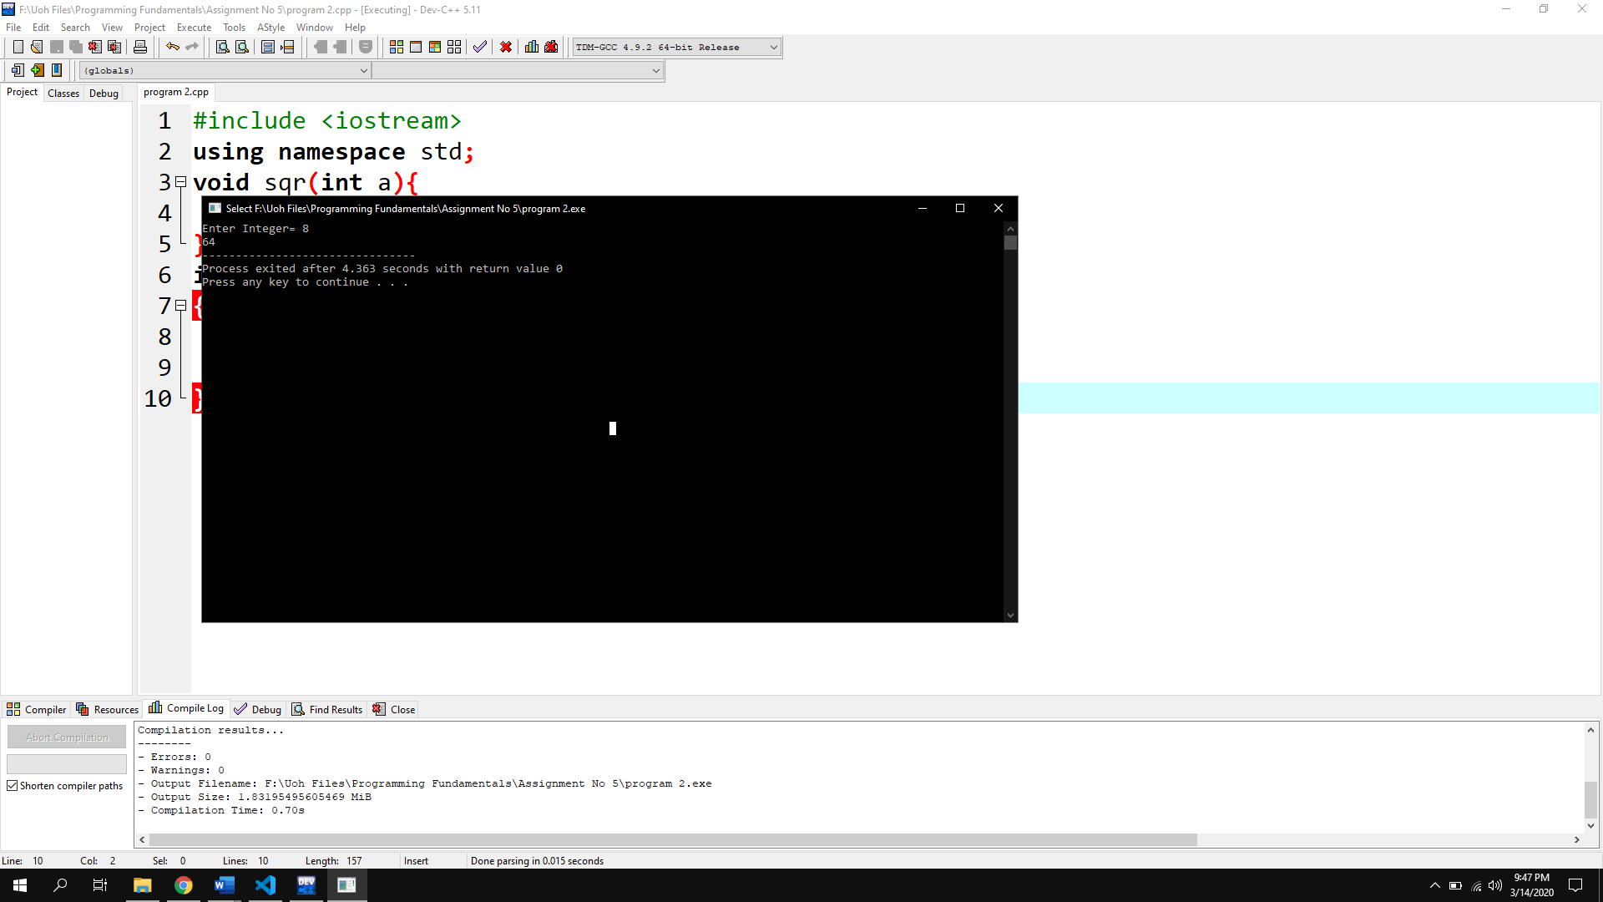

Program No 3:

|  |
| --- |
| #include <iostream>  using namespace std;  void average1(float a,float b, float c){  float sum=a+b+c;  float ave=(sum*100)/300;  cout<<ave<<"%";}  int main()  { float a,b,c;  cout<<"Enter three numbers for Average= ";cin>>a>>b>>c;  average1(a,b,c);} |

Output:

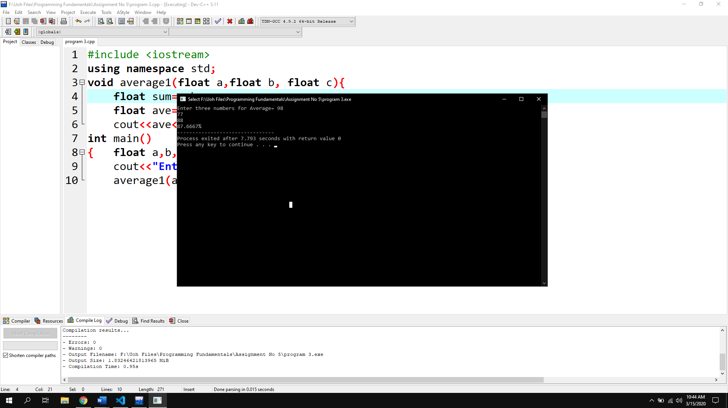

Program No 4:

|  |
| --- |
| #include <iostream>  using namespace std;  int cube(int n)  {return n*n*n;}  int main()  { int r;  do{int n;  cout<<"Input a number= ";cin>>n;  cube(n);  cout<<cube(n);  cout<<"\nEnter 0 to terminate program= ";cin>>r;  } while (r!=0);} |

Output:

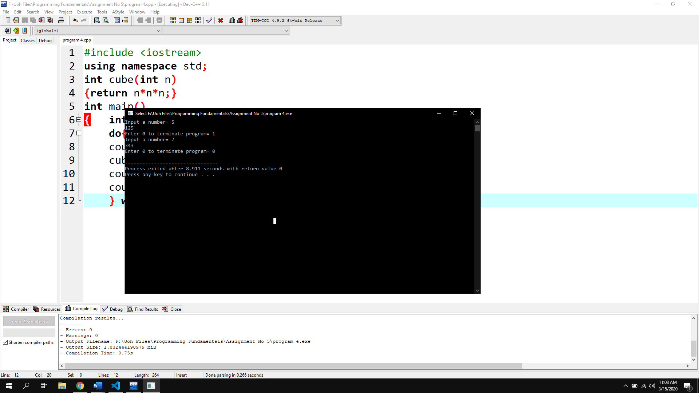

Program No 5:

|  |
| --- |
| #include <iostream>  using namespace std;  int average(int l,int w)  {return l*w;}  int main()  { int l,w;  cout<<"Input length= ";cin>>l;  cout<<"Input Width= ";cin>>w;  cout<<"average= "<<average(l,w);} |

Output:

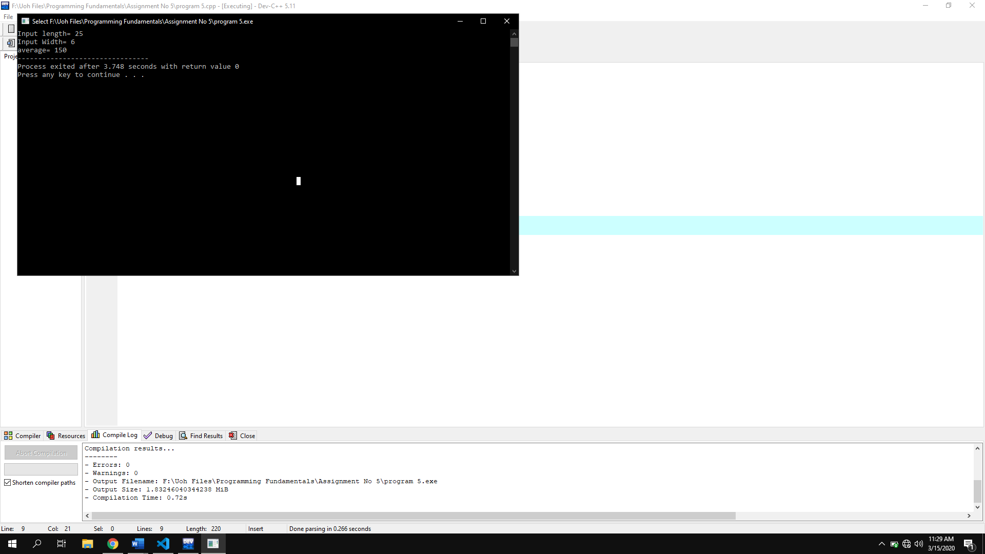

Program No 6:

|  |
| --- |
| #include <iostream>  using namespace std;  void printdate(int day=0,int month=0,int year=0)  { int termi;  do{  int day,month,year;  char select;  cout<<"Enter Day= ";  cin>>day;  cout<<"\nEnter Month= ";  cin>>month;  cout<<"\nEnter year= ";  cin>>year;  if (day>=1 && day<=31 && month>0 && month<13 && year>0)  {  cout<<"Enter d for Day/Month/Year\nEnter m for Month/Day/Year\nEnter y for Year/Month/Day= ";  cin>>select;  switch (select)  {  case 'd':  cout<<day<<" / "<<month<<" / "<<year;  break;  case 'm':  cout<<month<<" / "<<day<<" / "<<year;  break;  case 'y':  cout<<year<<" / "<<month<<" / "<<day;  break;    default:  cout<<"You entered invalid character!";  break;  }  }  else  {  cout<<"You Entered invalid Date";  }  cout<<"\nEnter 0 for termination= ";  cin>>termi;  }while (termi!=0);  }  int main()  {  printdate();  } |

Output:

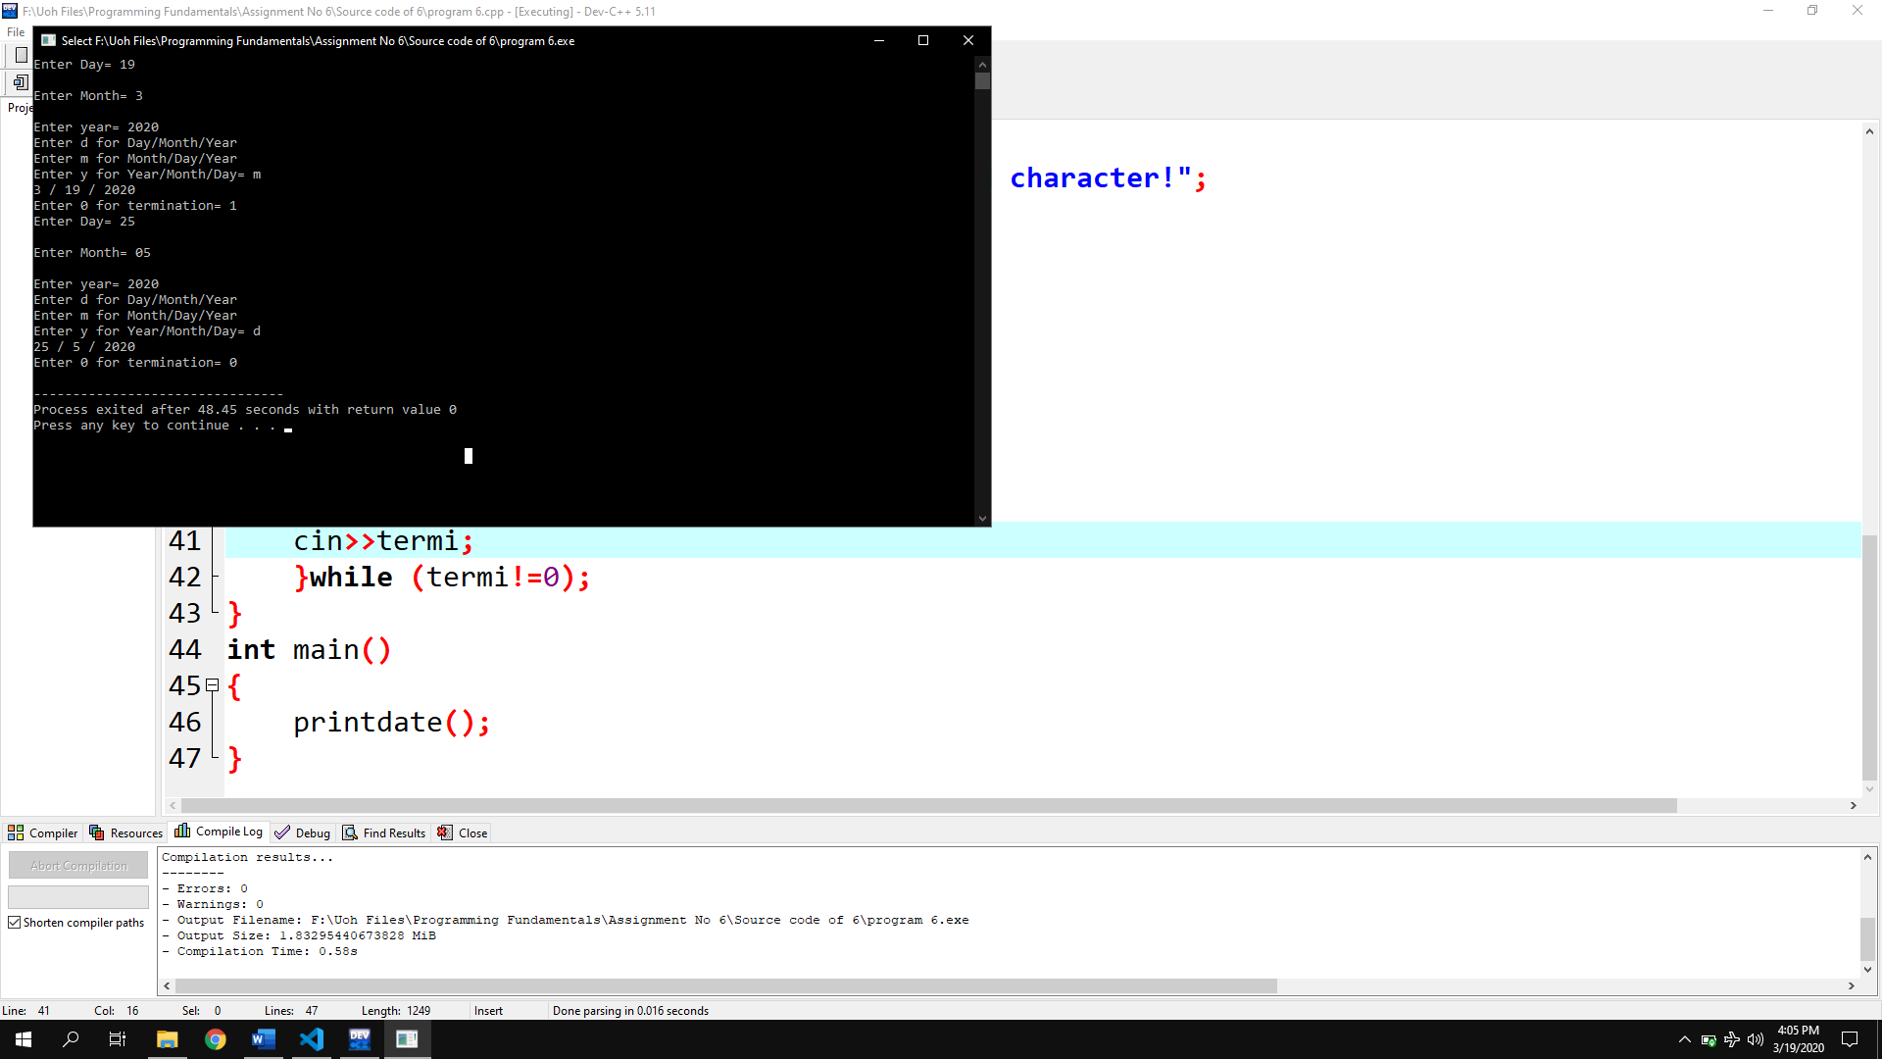

Program No 7:

|  |
| --- |
| #include <iostream>  using namespace std;  bool isleapyear(int year=0)  { int terim;  do  {  cout<<"Enter year to check= ";  cin>>year;  if(year%100==0)  {  if (year%400==0)  {  cout<<year<<" is a leap year";  }  else  {  cout<<year<<" is not leap year";  }    }  else if (year%400)  {  cout<<year<<" is a leap year";  }  else  {  cout<<year<<" is not leap year";  }    cout<<"\nEnter 0 to terminate program= ";  cin>>terim;  } while (terim!=0);  return year;  }  int main()  {  cout<<isleapyear();    } |

Output:

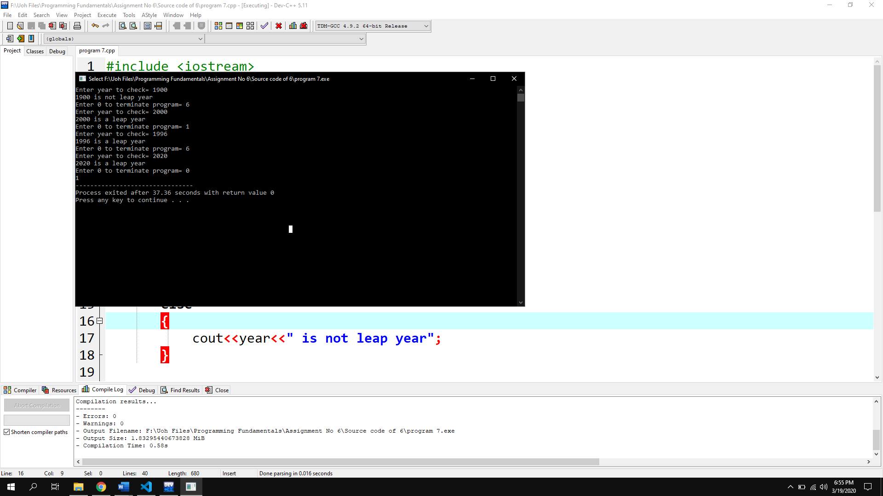

Program No 8:

|  |
| --- |
|  |